1.1 Place the optical breadboard on top of the airtable. In doing so, make sure that your surgical microscope, as well as, yourself can easily access all of the board.

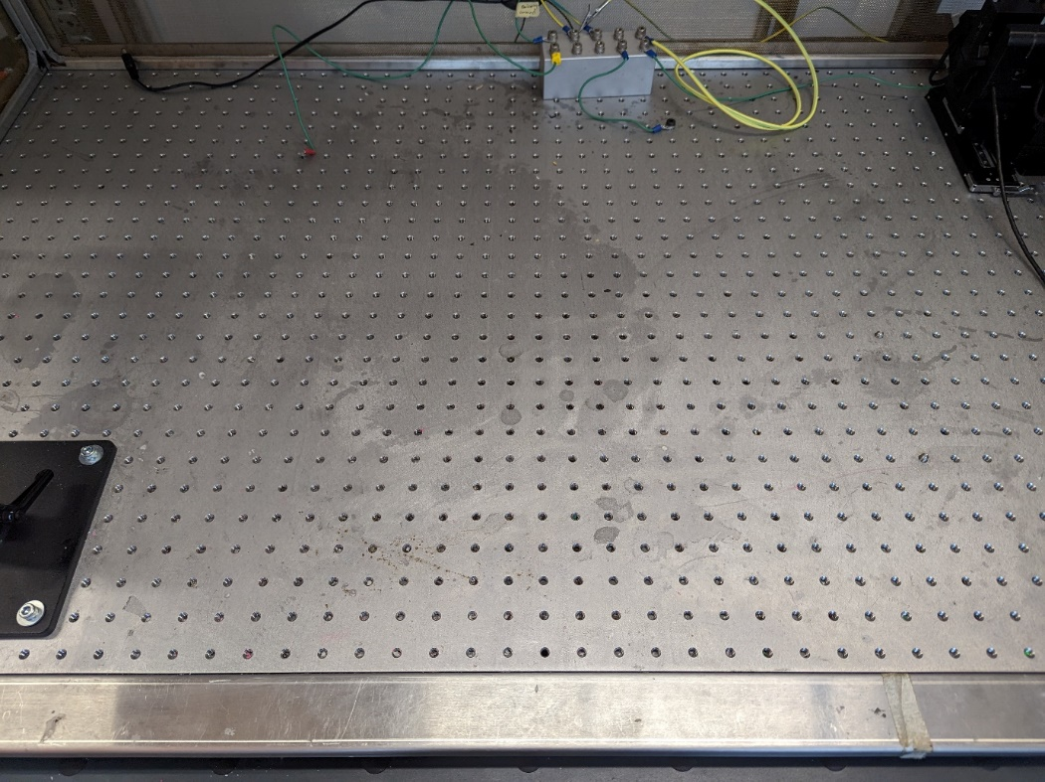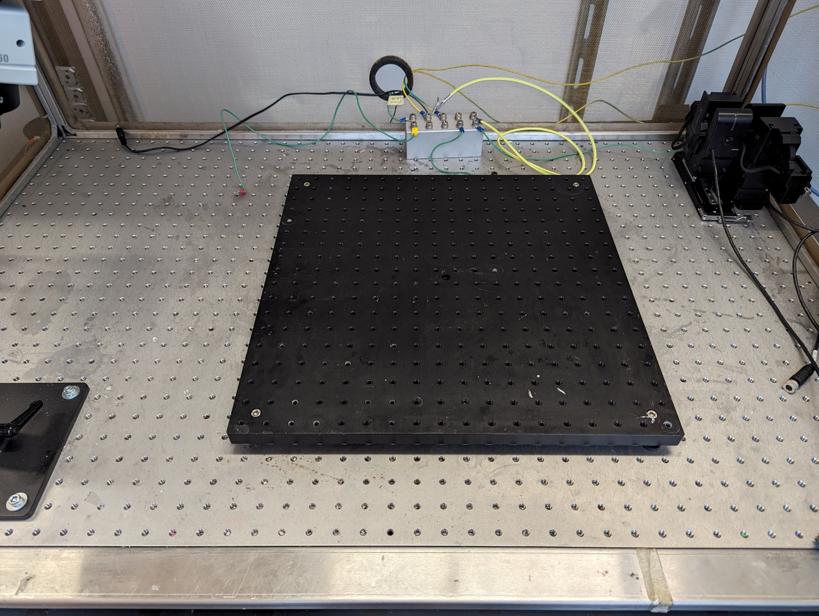

Range of scope

1.2 Screw a 2cm M6 or x imperial bolt into the x cm thorlabs rod (if it doesn’t have one already). It is important to note that you do not want your manipulator to block the vertical range of your microscope. Therefore take into account the working distance of your microscope when selecting the length of the ThorLabs rod.   
1.3 Attach the 6cm long thorlabs rod into the optical breadboard. Make sure that your micromanipulator will be placed close enough that it can reach most of the breadboard. For us we place the rod x cm from the center. Our manipulator is on conveniently placed on a moving rails this way we have enhanced control by moving it in and out of the setup.  
1.4 Fasten the rails of the micromanipulator to the rod using a ring(is this the proper way to connect according to Sensapex?) and an other 2cm 6M or x imperial bolt.   
1.5 Use the SensaPex grounding site to ground the micromanipulator by utilizing the tiny screw to fasten a grounding wire with a star connector.

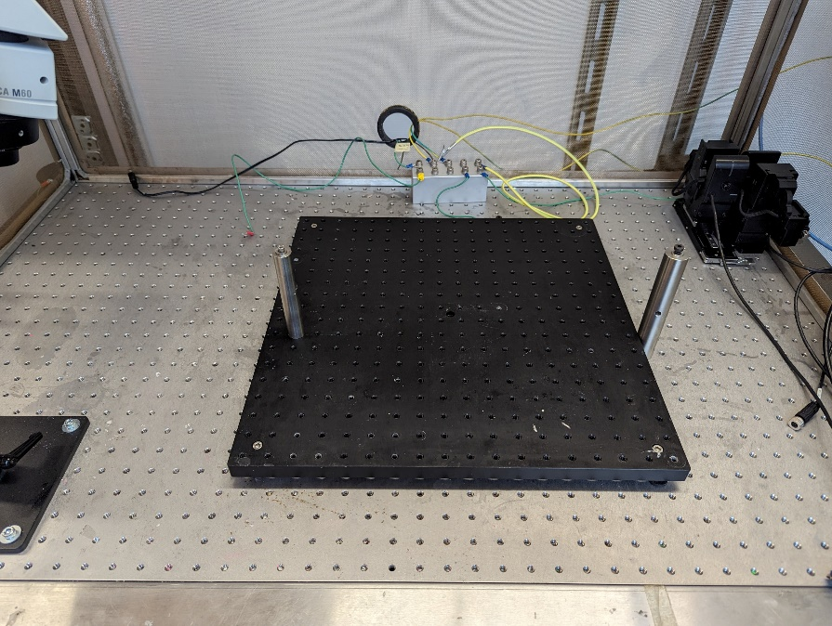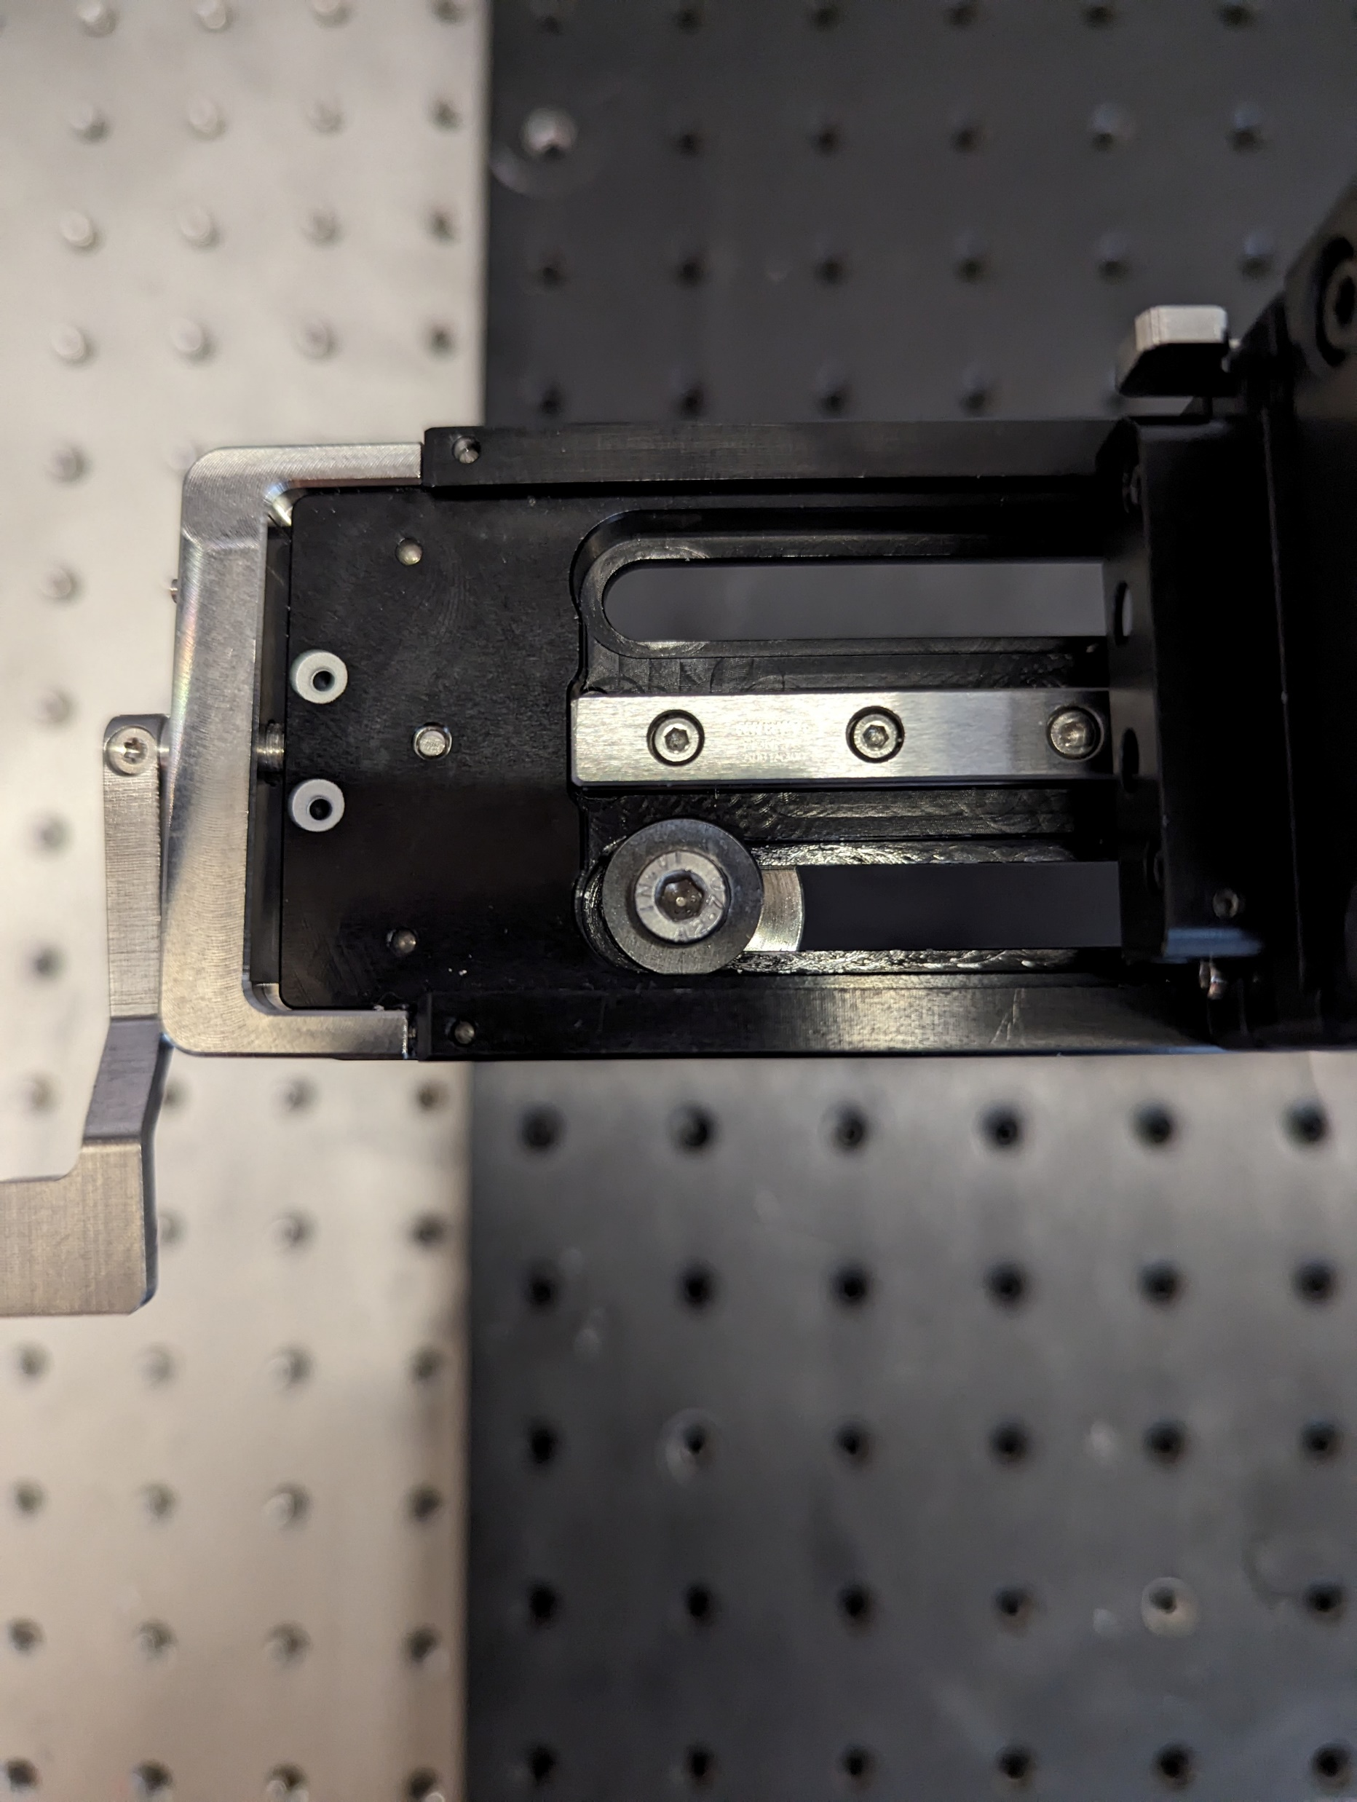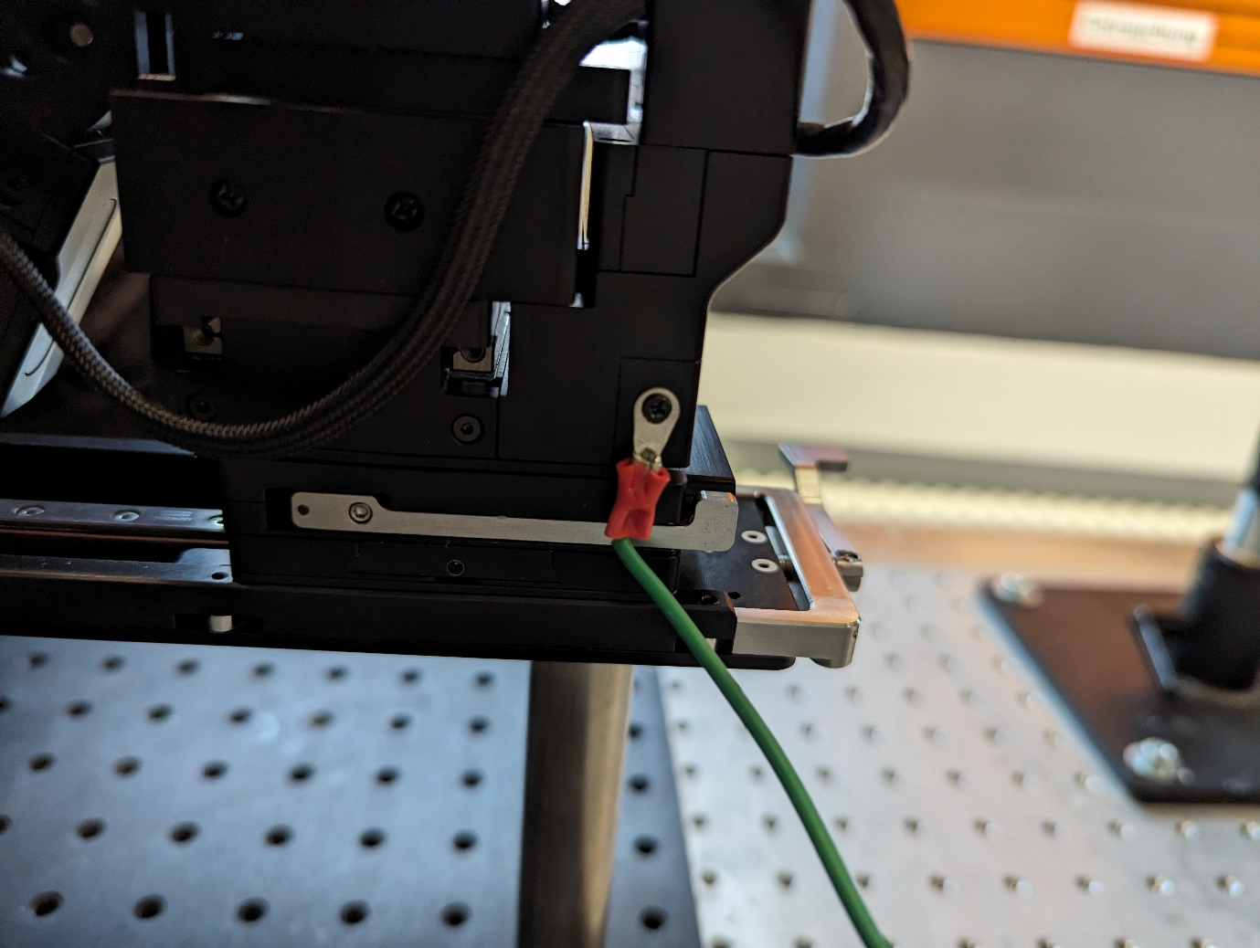

# Animal restraint

2.1 Place the animal restraint baseplate (where is this made, where is this from?) in the middle of the optical breadboard and secure its placement using two 2cm 6m screws. Make sure that that you place it within the range of the microscope  
2.2 Place the thorlabs rod with a xM screw to the AR baseplate.  
2.3 Horizontally fix a x cm x diameter rod to the vertical rod using a 90degree rod connector and a xM bolt.

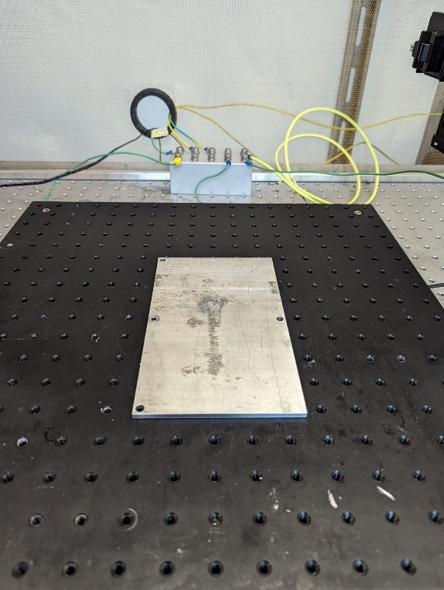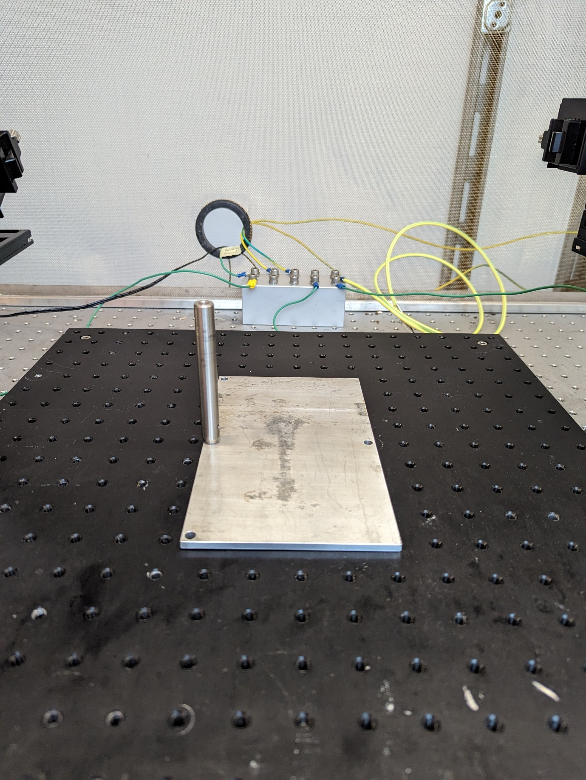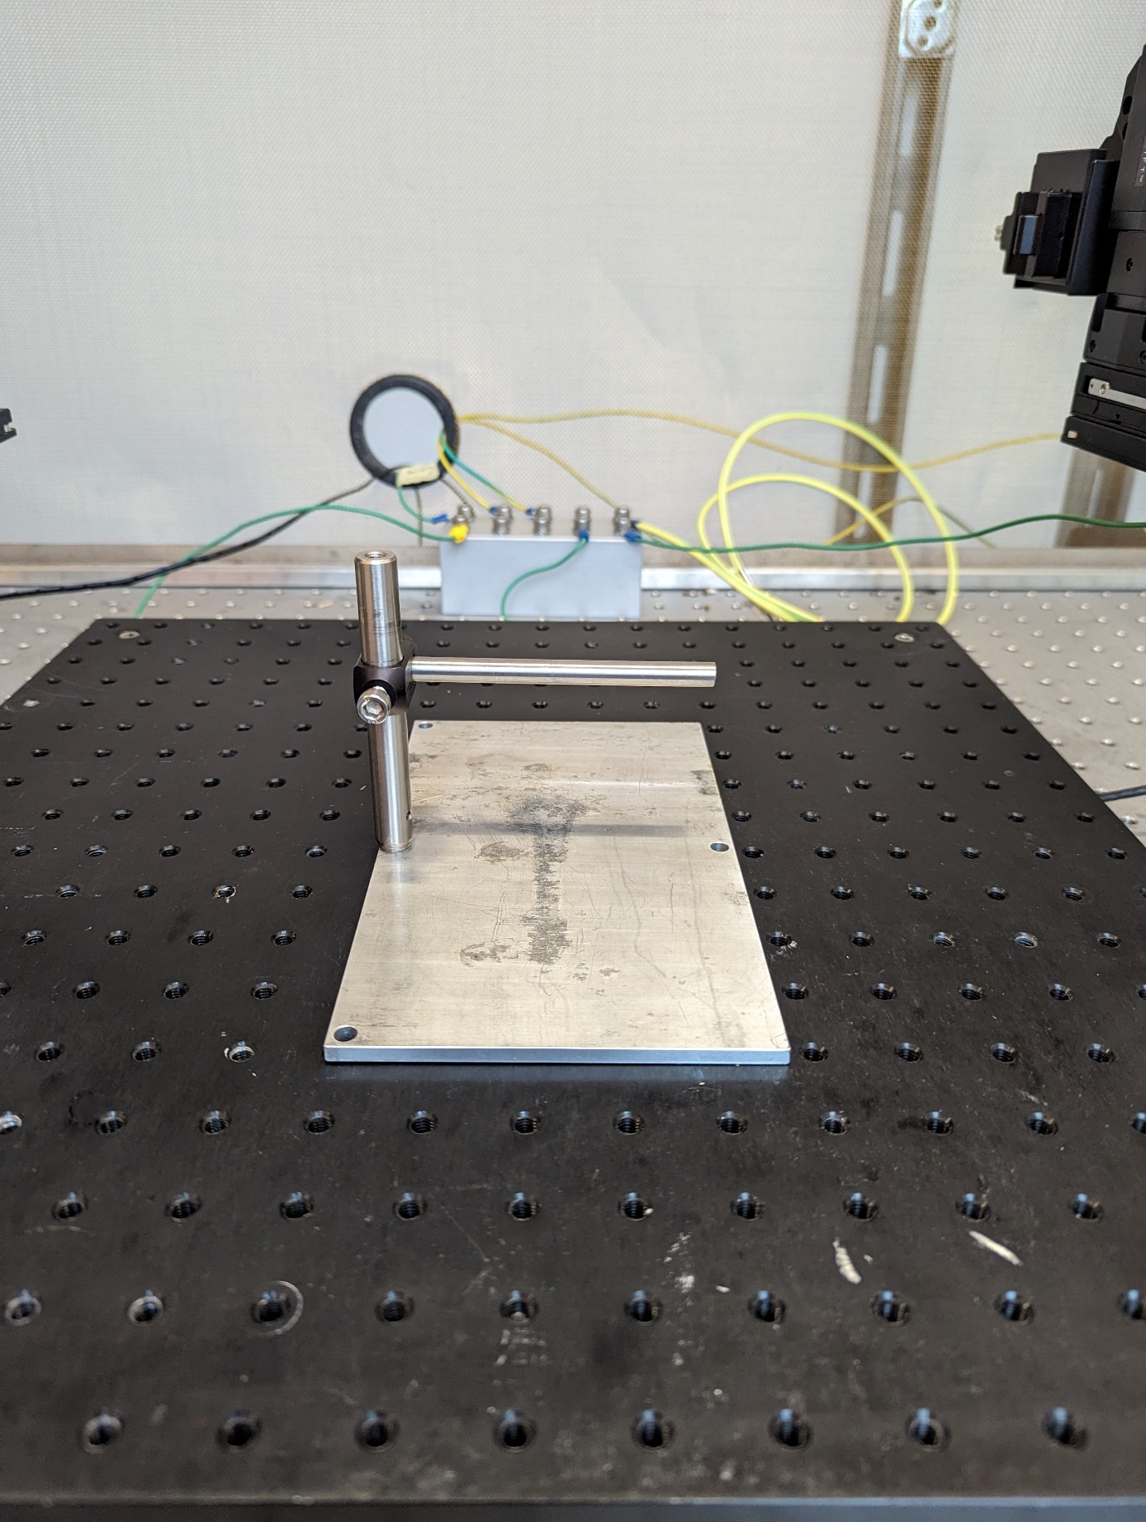

2.4 Connect the rod with the attached headbar holder. One can choose to wrap the connecting point with Kapton tape to minimize electrical noise from the animal through the headbar to the rest of the setup.   
2.5 Place the plastic/acrylic tube Do we cut the tube ourselves? directly underneath the headbar holder. Make sure that the holder has the correct height from the AR baseplate. Note that if you notice your animal being too pressed or lifted by the height of the holder that you should adjust the placement.   
2.6 Finally you should be able to place have the micromanipulator directly above the headbar holder.

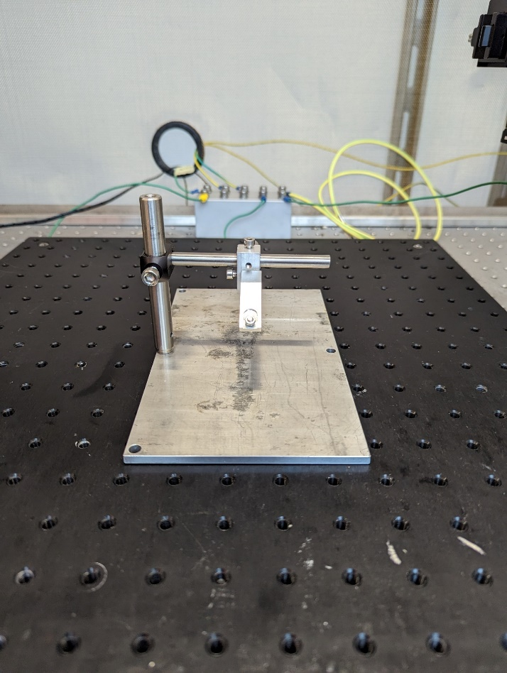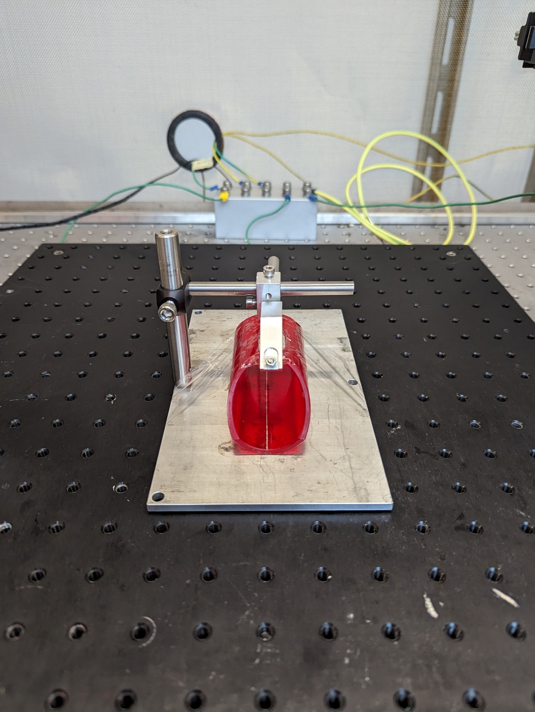

# Water reward

3.1 Position lick detector holder/flexarm so that it can easily reach the animal restraint compartment. The holder should be flexible enough to reposition easily so that the animal can reach and the licking spout.

3.2 Connect a crocodile clamp to the flexarm.

3.3 Fasten the holder to the optical breadboard. We use a Thorlabs clamping fork and screw this into the breadboard using two 2cm 6M screws. This then clamps the flexible holder.

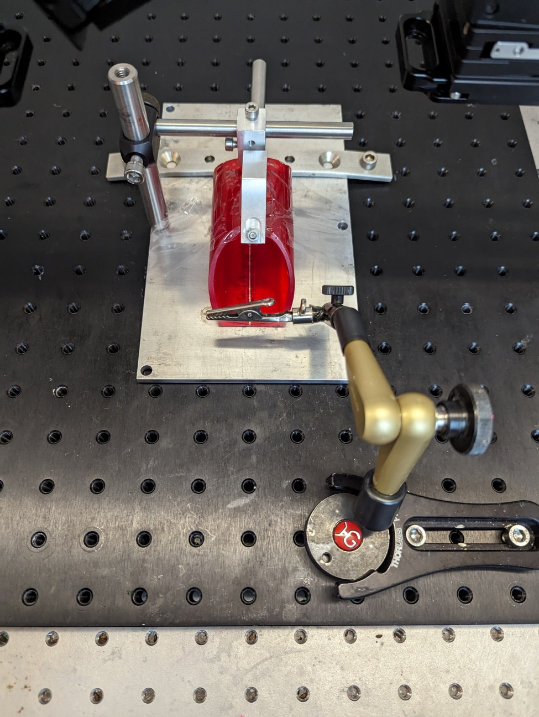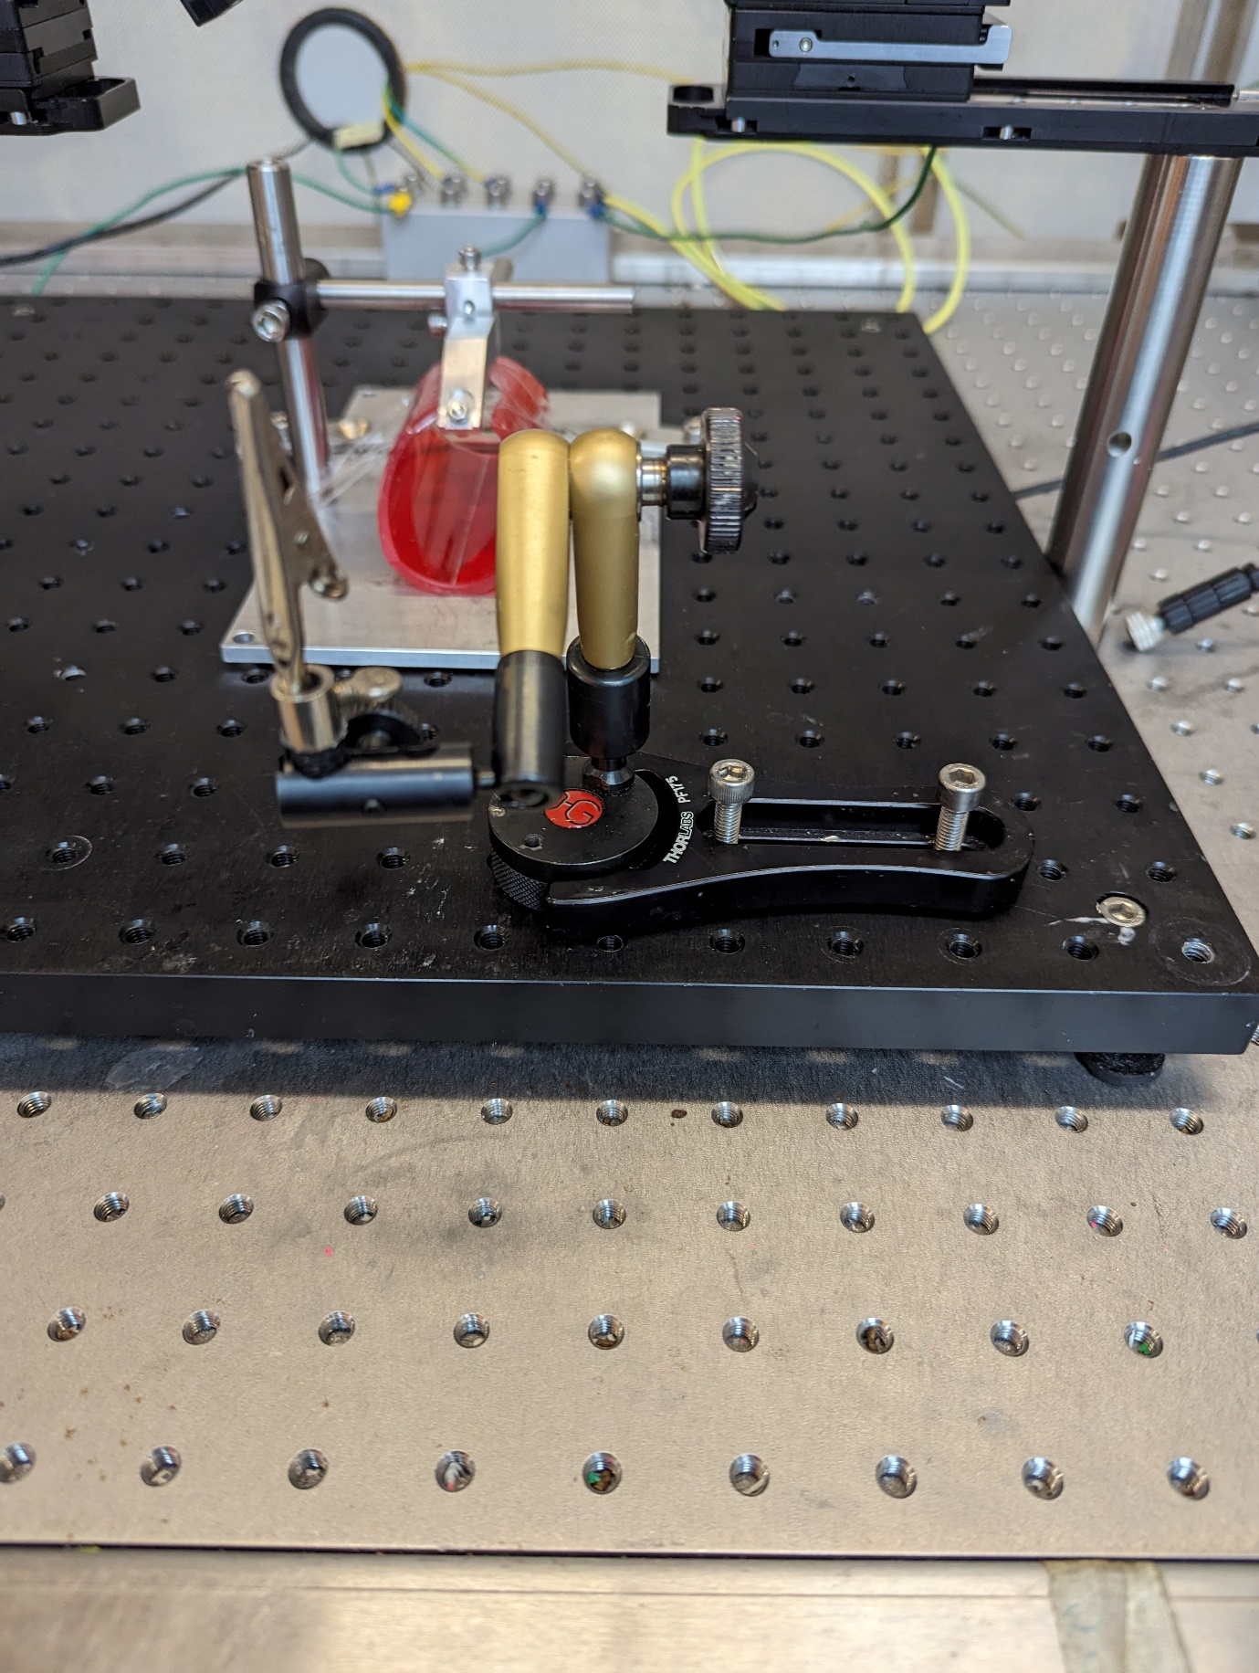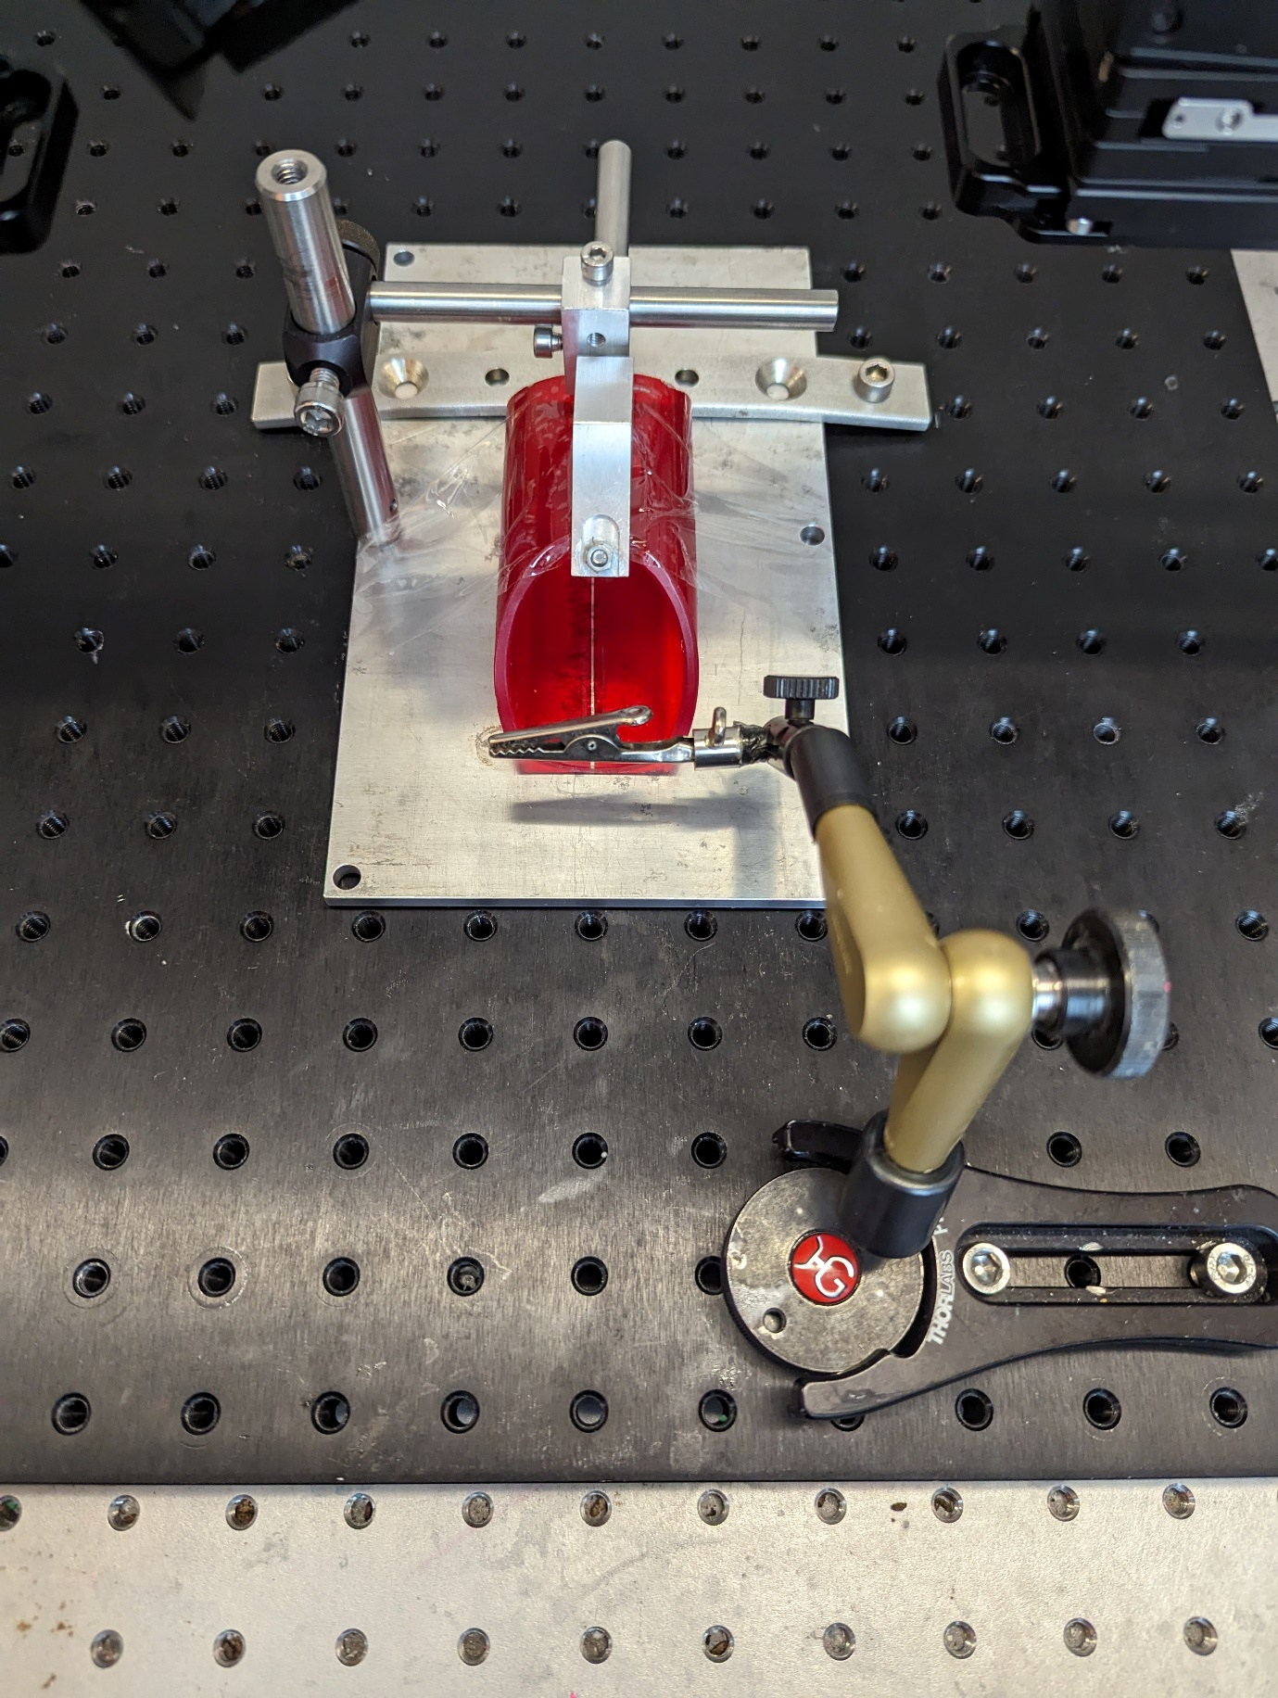

Range

3.4 Attach a water reservoir (we’re using a syringe) at an elevated position around the setup. CAREFULL, water and electronics do not go well together. Make sure that even if you spill water when refilling you do not spoil your electronics.

3.5 Connect the tubing to the water reservoir. We are using xID/yOD tubing that is connected through a x tubing connector.

3.6 Slightly below the water reservoir attach the solenoid and clamp the tubing with the solenoid. CAREFULL the solenoid will become hot during your experiments and should not be touched.

3.7 Connect a licking spout to the other end of the tubing. We are using a cut off, blunted x gauge needle.

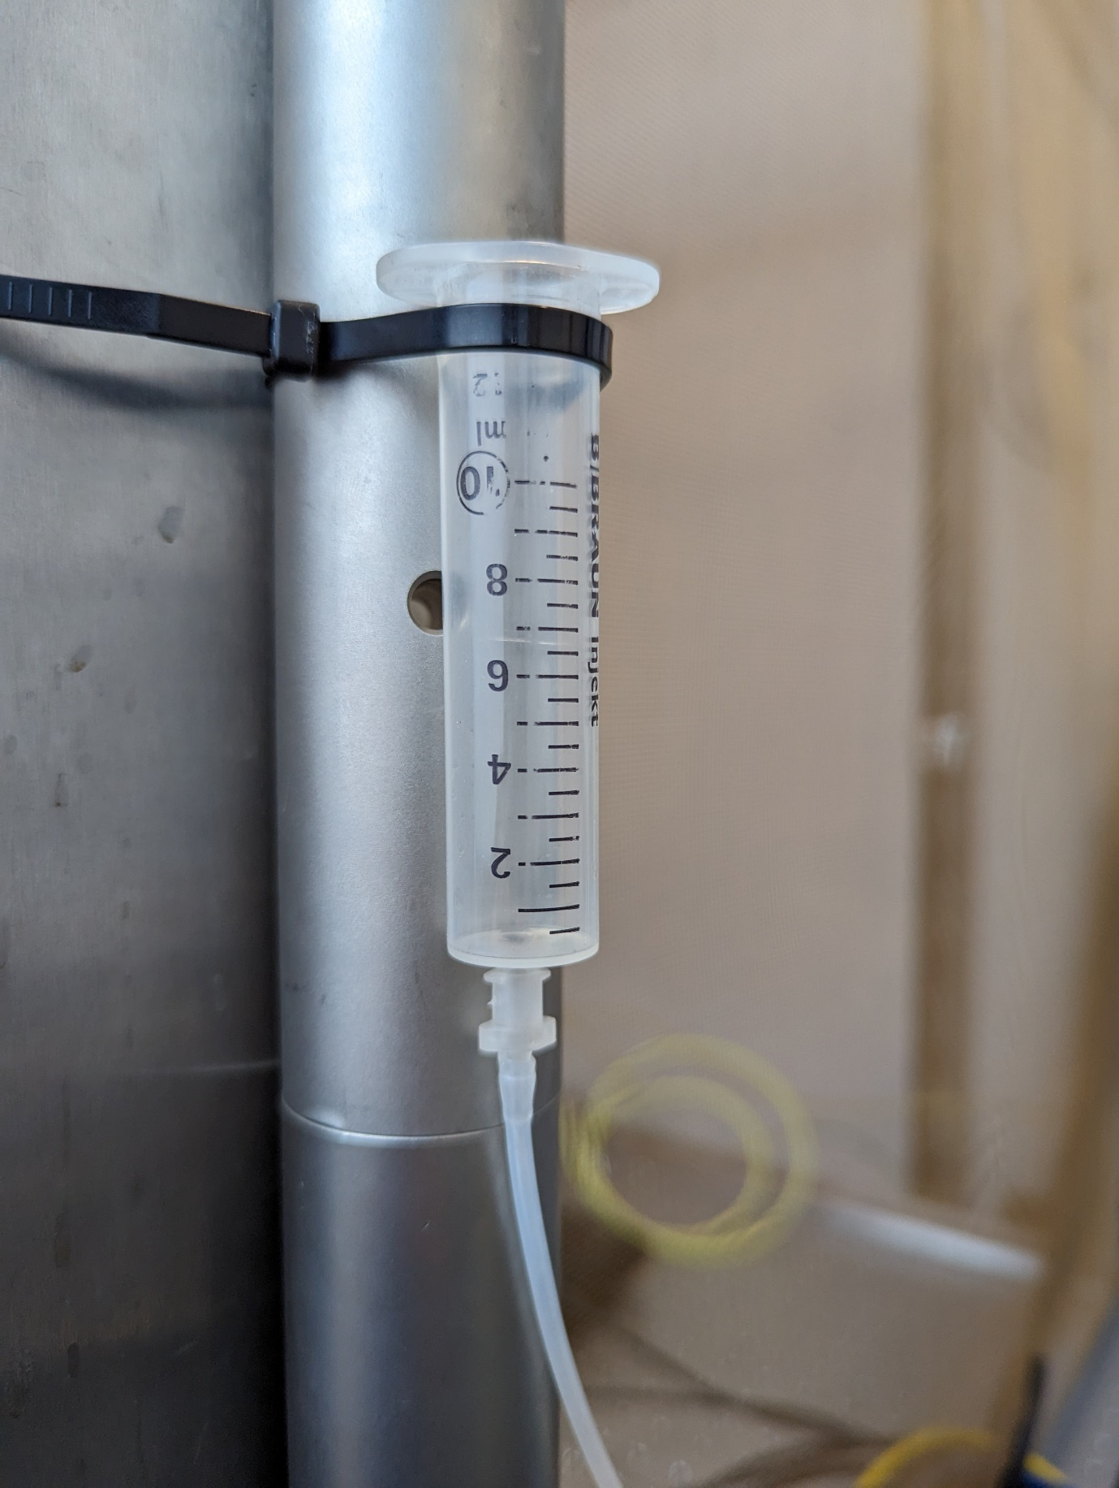

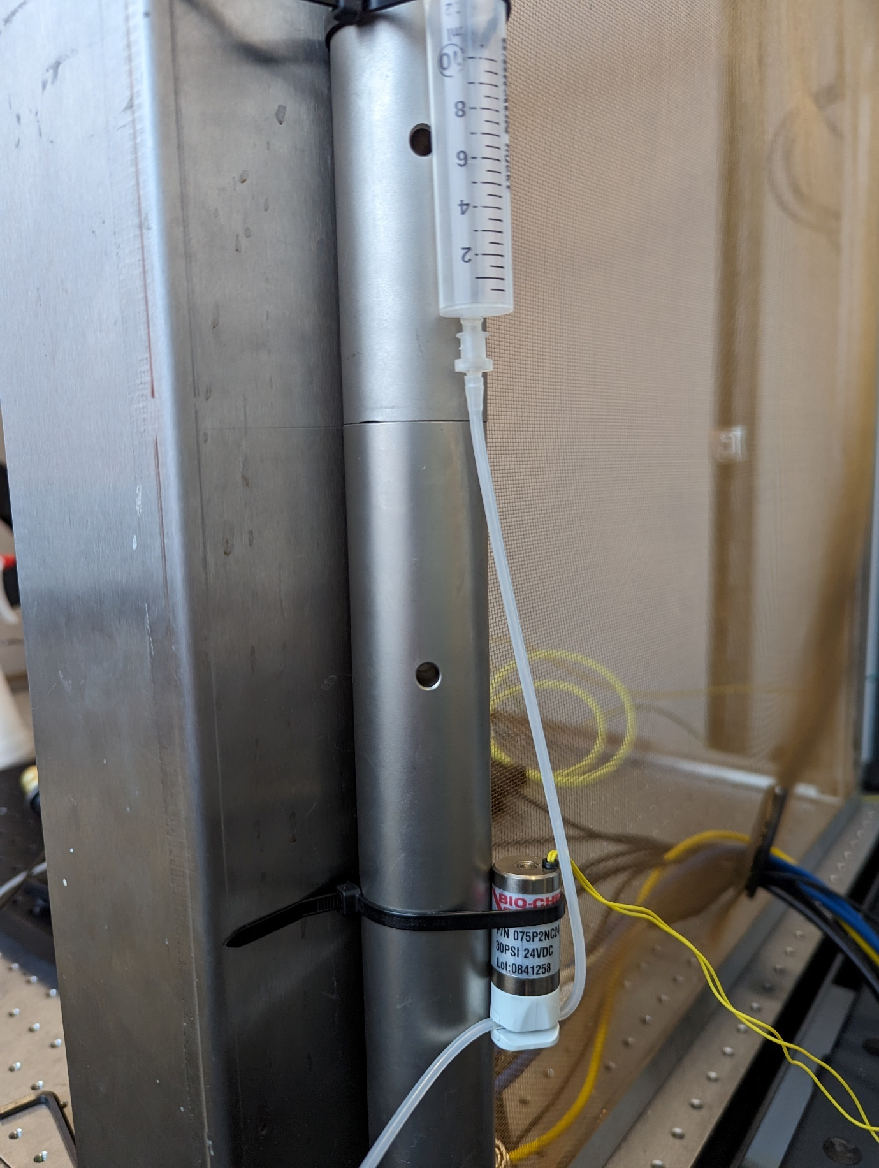

3.8 Stick the licking spout through the piezo sensor and clamp the sensor with the crocodile clamper.

3.9 Connect the piezo sensor and the solenoid to the MultiTool (wiring). Calibrate the sensitivity by having an animal lick the sensor and determine what should and should not be counted, this is visualized by the light on the display. You can modulate the gain of the signal. Additionally, you can alter the opening delay and duration of the solenoid. This is done by holding the x button for one second and then twisting the knob.

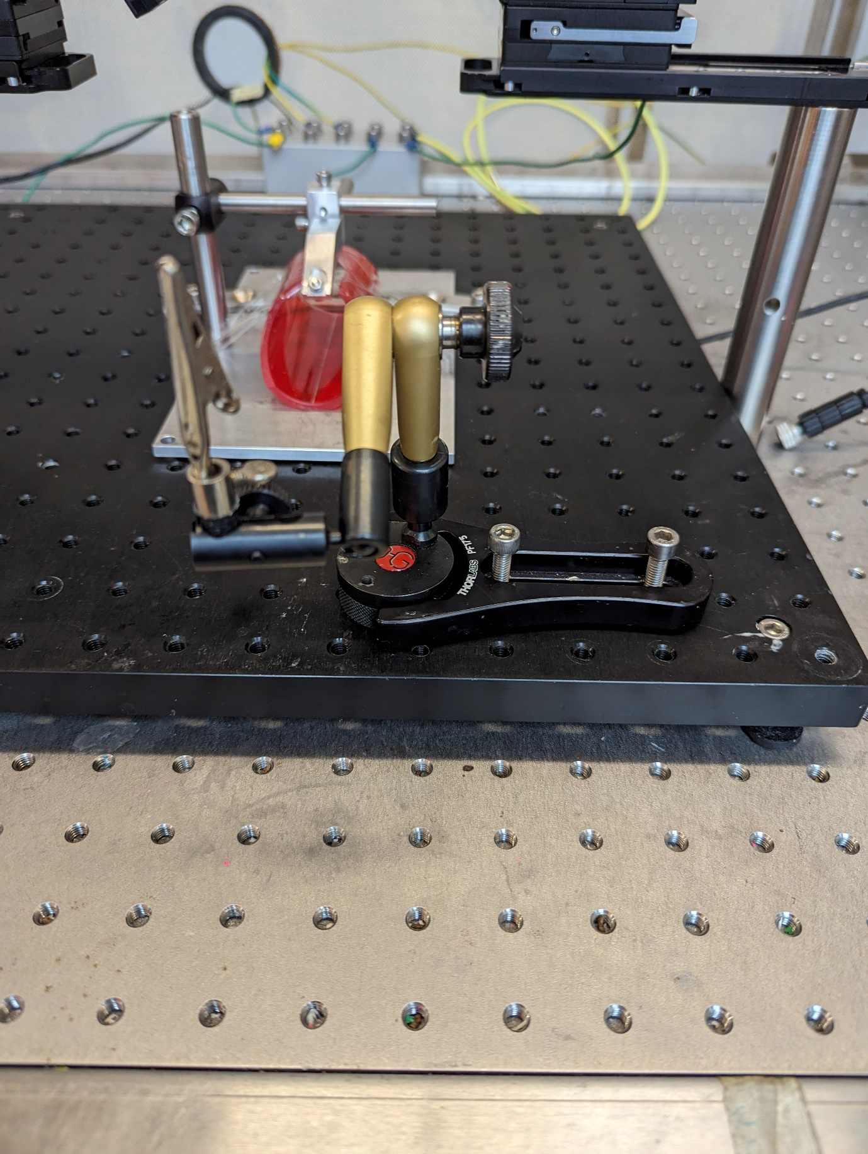

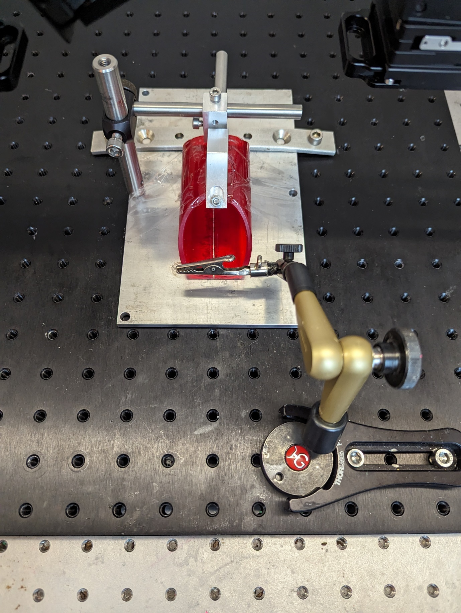

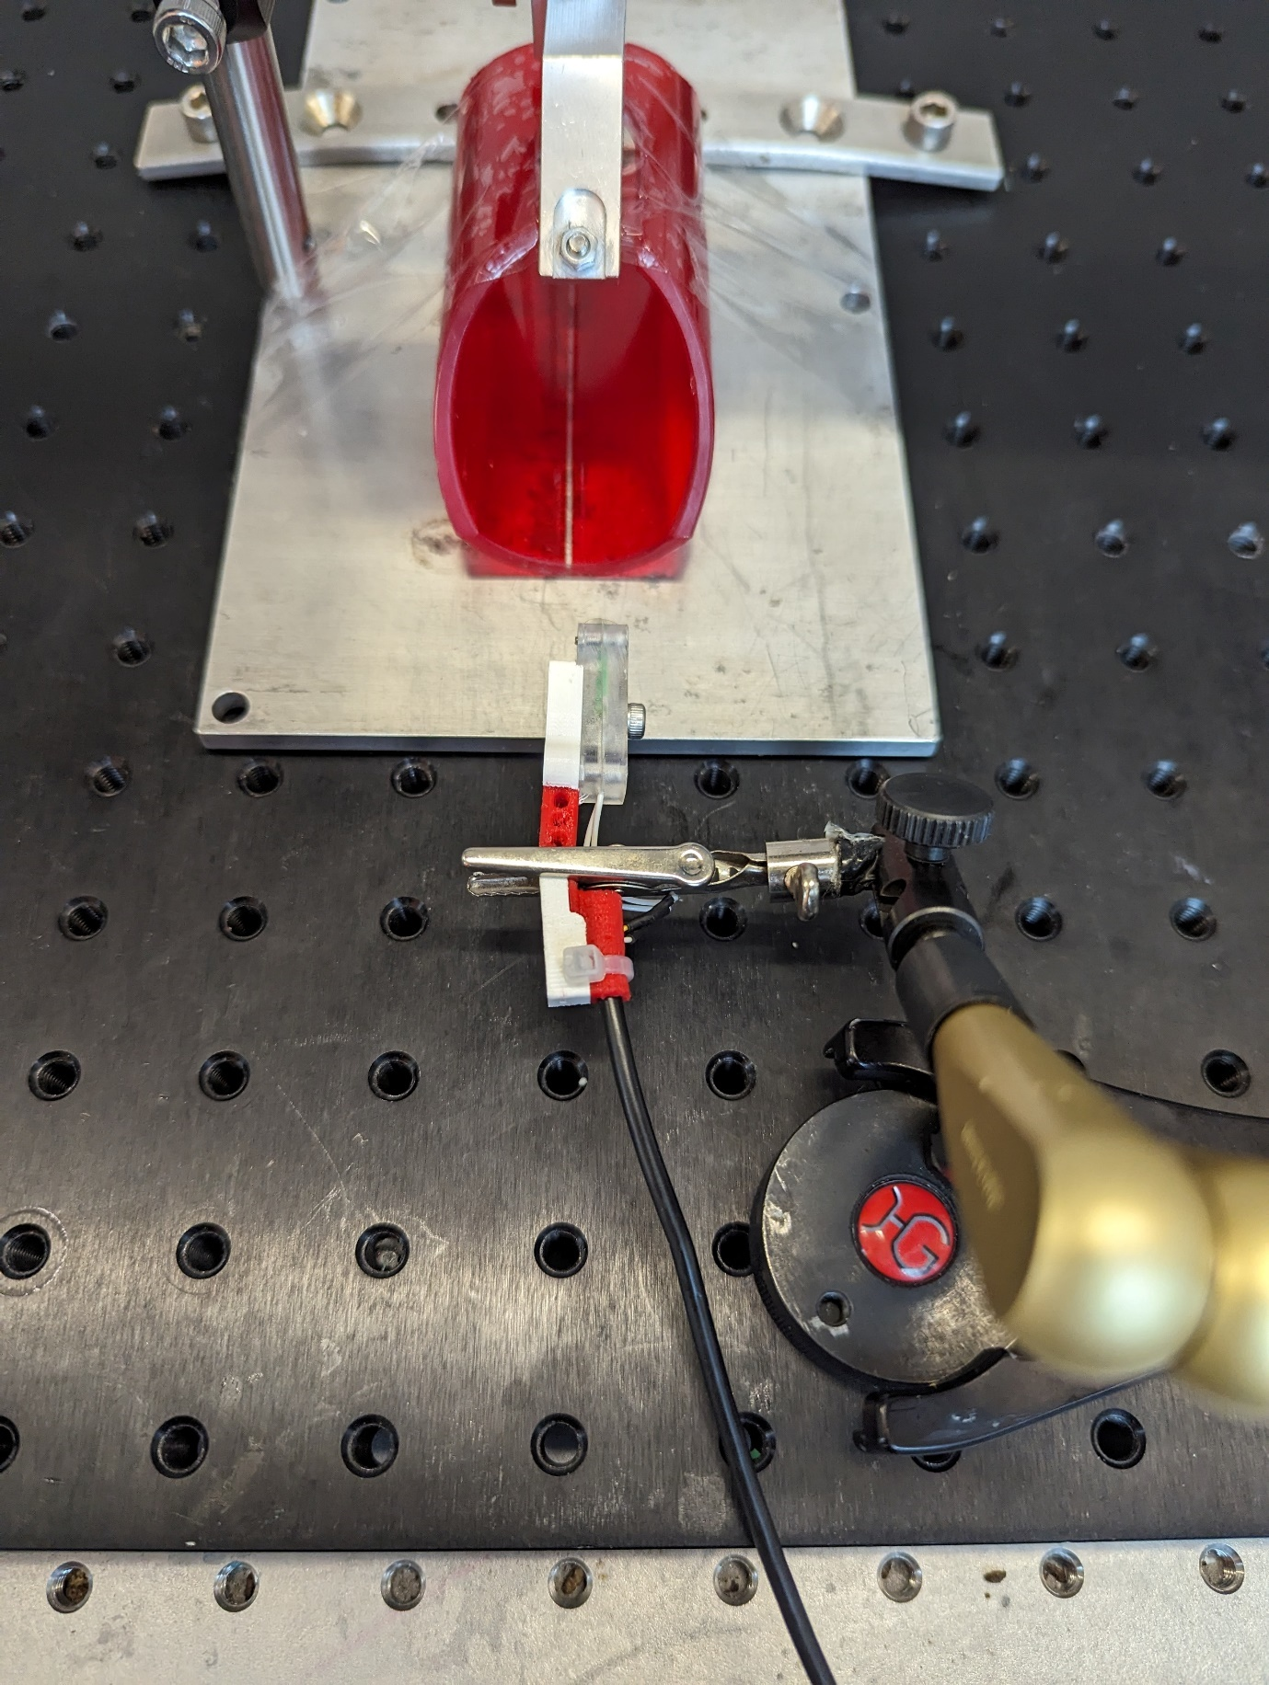

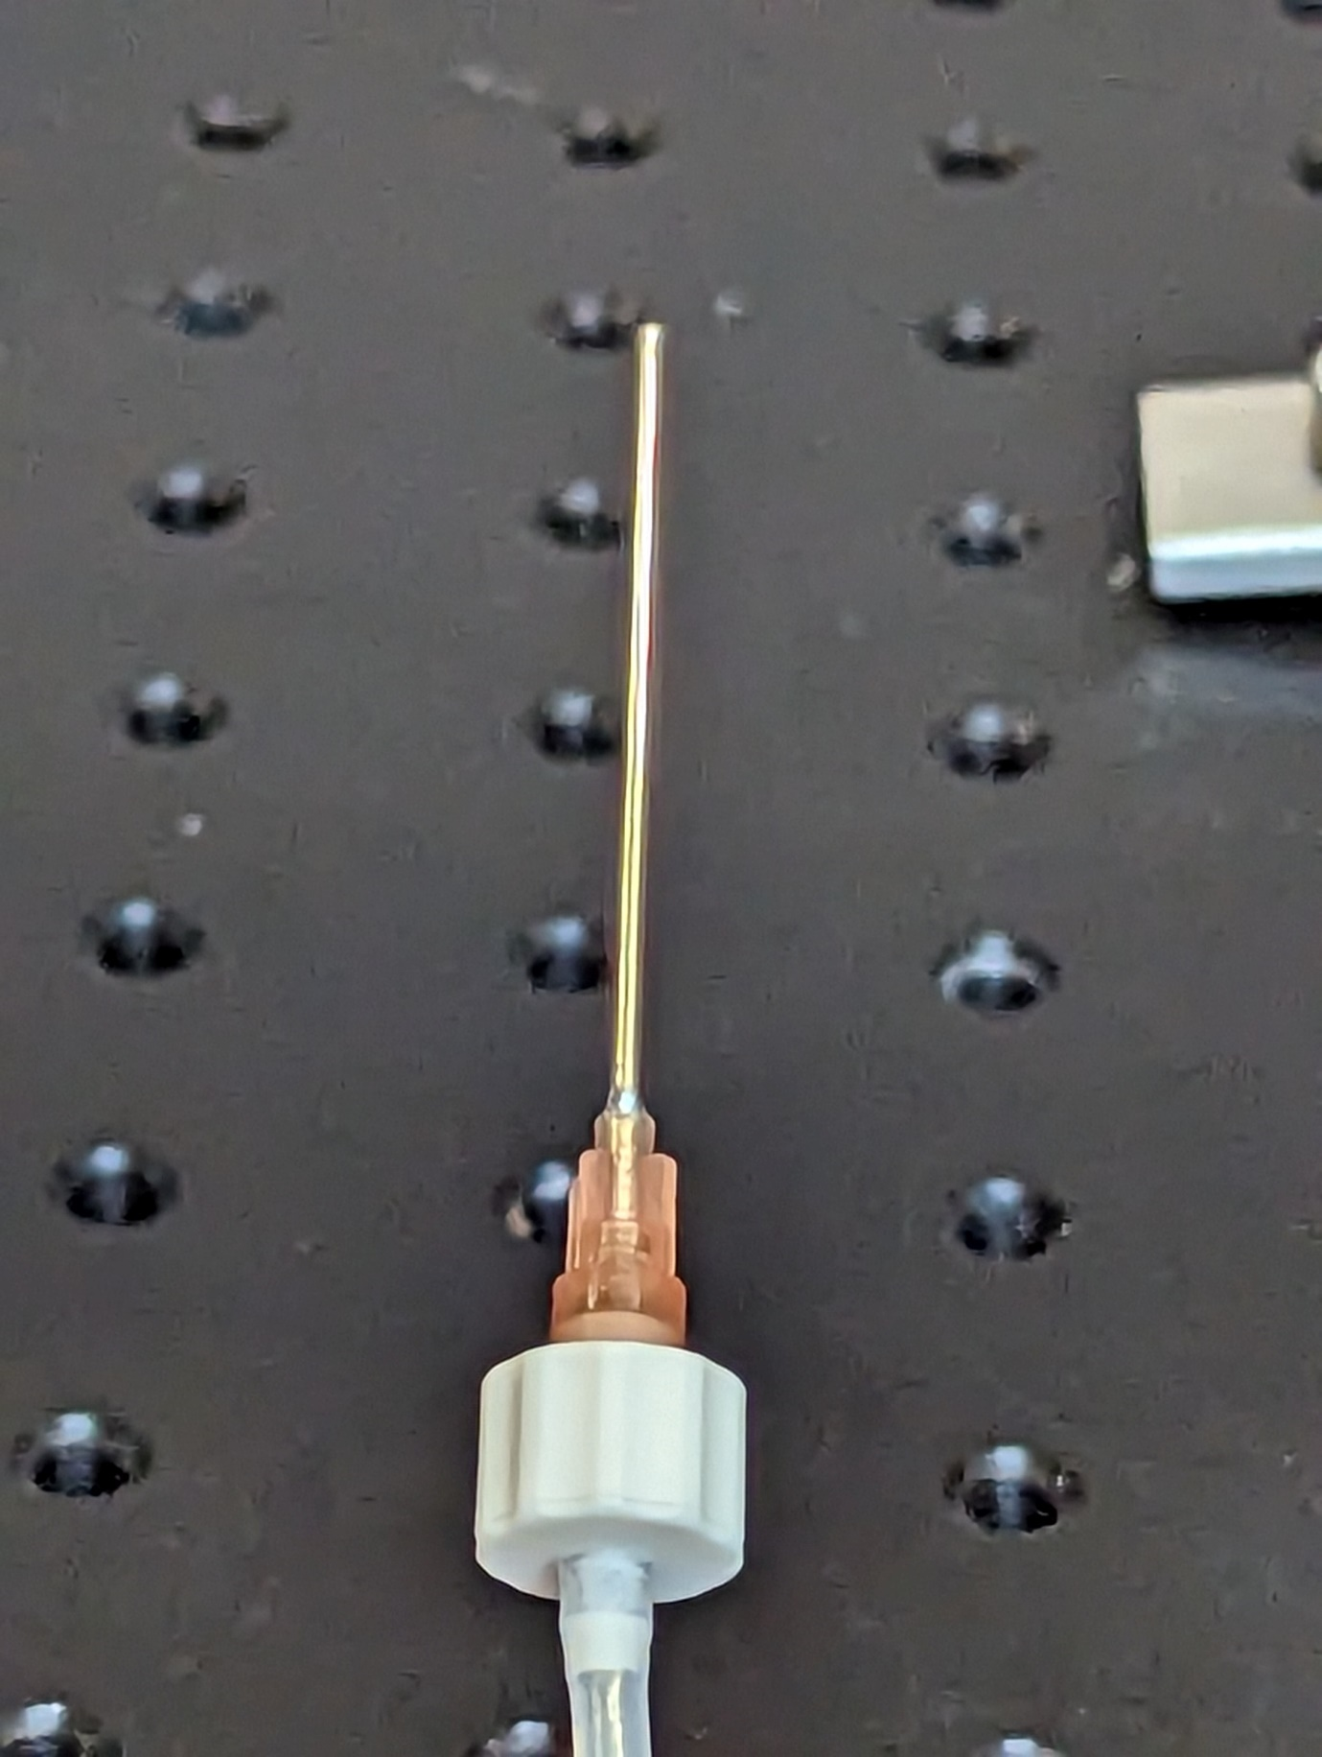

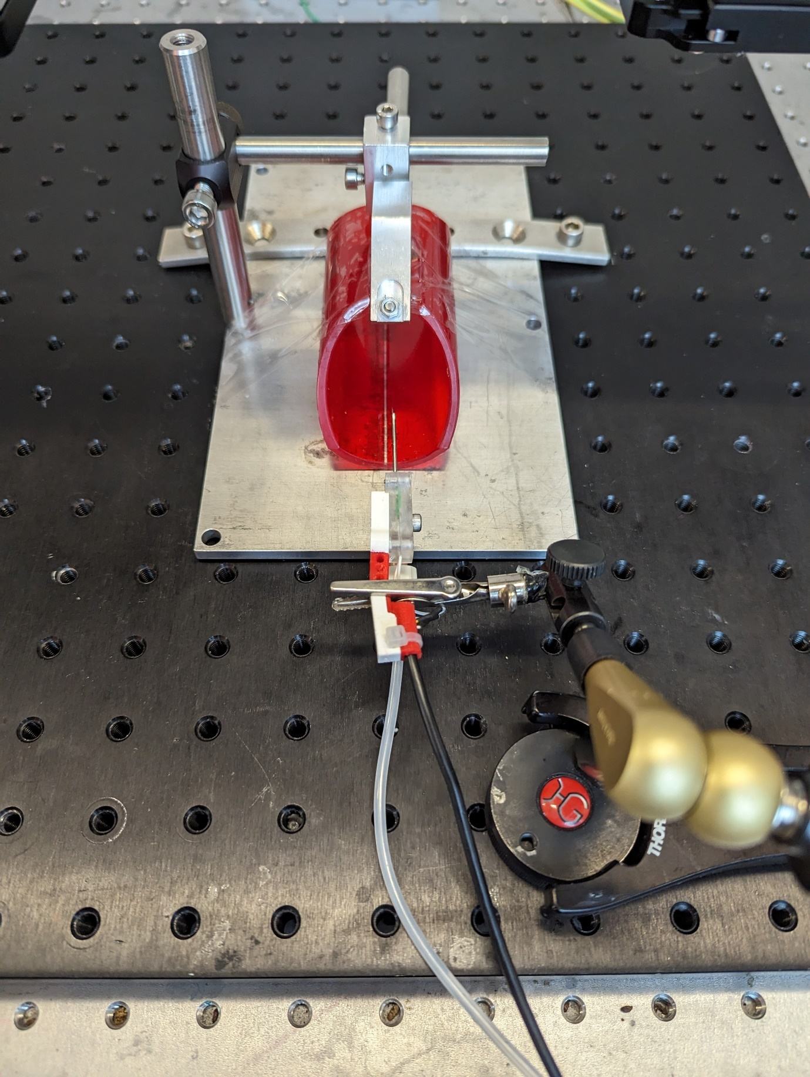

# Stimulation component

4. Connect the BPOD shield to the Arduino DUE

4. Make a BNC to open wire. One can do this by cutting open a BNC connector and soldering two wires to the positive and negative pole within the wire.

4. Interface the Arduino DUE and the Arduino UNO with eachother conform the following wiring diagram.

4. Connect the BPOD Serial Out 1 to the Serial port of the BPOD shield.

4. Use the BNC to open connector to connect the Arduino Uno with the stimulus isolator. The Arduino uno is meant to configure the stimulation pulsetrain and waveform.

4. Create a more stable electrode by cementing the electrode to a glass pipette.

4. Gently clamp the electrode with the electrode holder. Be careful that you do not clamp too hard as this might break the glass pipette.

4. Attach the positive (red) output of the stimulus isolator to the electrode using wires that end with a female gold pin.

4. Select directionality (cathodic-first) by pressing the polarity select button so that the light is on above the red wire.

4. For testing connect the negative (black) output to a wire and place it in saline together with the electrode. Switch on the audio output on the Stimulus isolator and run the BPOD TEST PROTOCOL. When configured correctly you should hear a ‘low’ short ‘beep’ once a stimulus is given. Try to open the circuit by moving the negative wire out of the saline. You will now hear a high long ‘beep’. When you hear this sound during experiments it means that your connection is not correct. Likely the reference has been disconnected.

4. For experiments connect the negative (black) output to the well, preferably using the male gold pin that is inserted into the recording chamber.

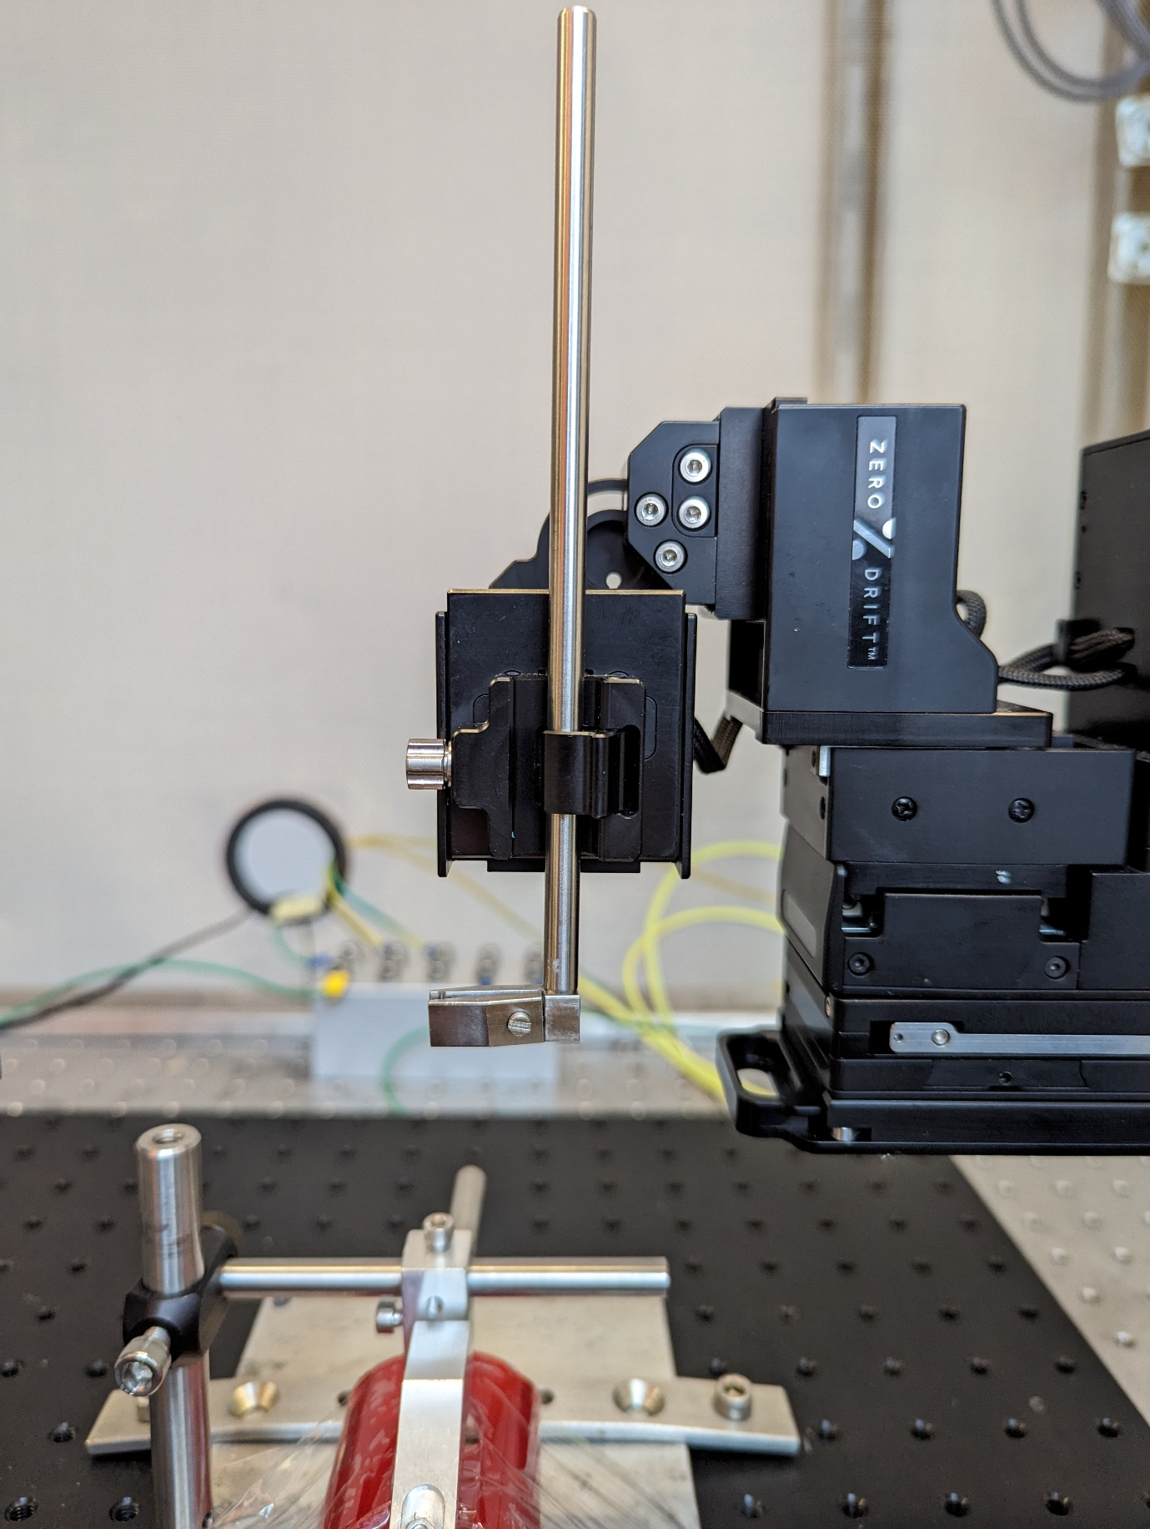

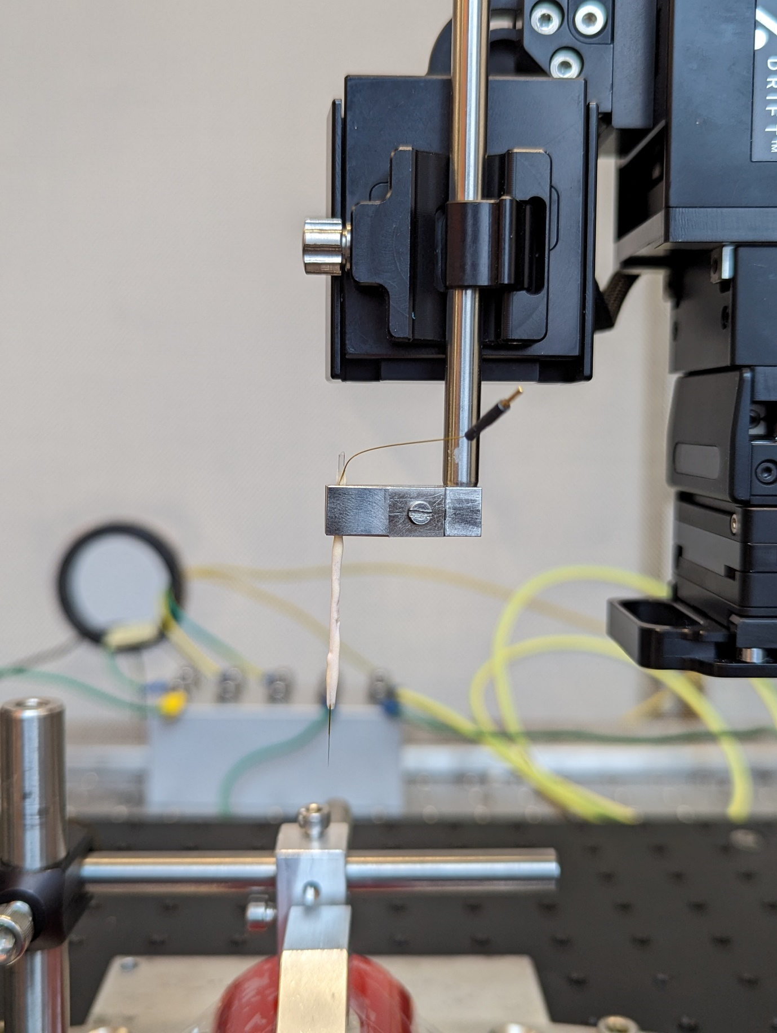

# Camera component

5. Attach the basler cameras to the camera holder using tiny af screws.

Whisker cam

5.x.1 Attach the x lens for capturing whisker position. This results in a camera with a working distance of y.

5.x.2 To position the whisker camera (with a WD of x) we place a vertical rod x, y centimeters from the middle of the animal restraint. The minimum length of the rod is y.

5.x.3 At z-elevation place connect a horizontal rod with a minimum length of x using a 90degree rodconnector to the vertical rod.

Pupilcam

5.x.1 Attach the x lens for capturing the face/pupil dilation. This results in a camera with a working distance of y.

5.x.2 To position the whisker camera (with a WD of x) we place a vertical rod x, y centimeters from the middle of the animal restraint. The minimum length of the rod is y.

5.x.3 At z-elevation place connect a horizontal rod with a minimum length of x using a 90degree rodconnector to the vertical rod.

5. Connect the camera to the horizontal rod and position it directly above the animal. Once you have found the correct position clamp the camera holder to the horizontal rod.

5. Connect both cameras using the Basler to USB3 cable to a USB3 port in your computer.

5. Finally, connect the camera to the BPOD BNC OUT1 with a OPTO CALBE. You can connect two cables to BPOD BNC OUT1 if you are using a T-connector piece. Make sure that you use the OPTO OUT 3 pin to connect the camera.

5. Test the cameras.